**Comp1168 LabNo7**

Name: Wong, Jui Hsin

CRN: 50138

Student Id: 101559700

Date: 03/13/2025

* Q1

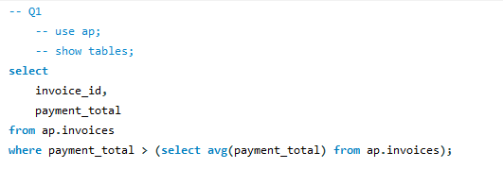

* Q2

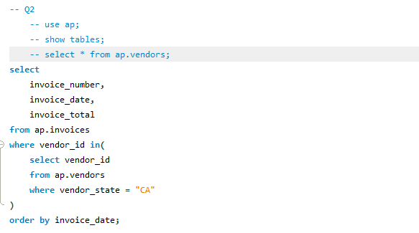

* Q3

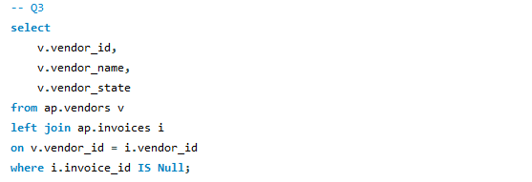

* Q4

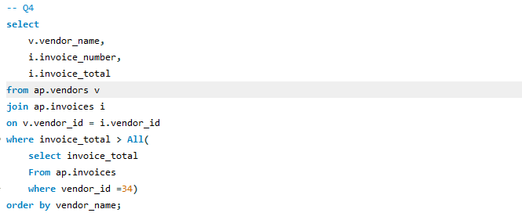

* Q5

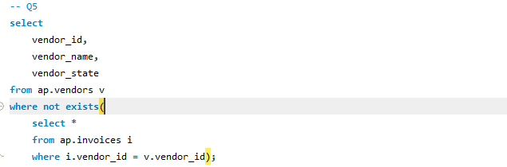

* Q6

